A Novel Note on Smart Cradle System

By:- Mr.Shivnarayan Vaidyanathan

UG Scholor,Dept of CSE,BITM,Ballari.

shivnarayan2799@gmail.com

______________________________________________________________________

Abstract:

This Paper portrays the configuration of a programmed cradle which fundamentally chips away at location of infant development with the assistance of a motion sensor. Motion sensor detects the movement of infant. After the location of enlivening of infant various occasions are terminated which incorporate sending notices to parents by google firebase and e-mail, swinging of cradle with the goal that the child feels good. The cradle likewise incorporates extra gimmicks like observing the temperature of the infant to give therapeutic thoughtfulness regarding the child and cautions the parents if the body temperature of the child goes above to given threshold temperature.

**Keywords**: AI,IOT,Sensor

Introduction:

As we all know the term IOT that is internet of things which is designed to save time and ease work. As far as time and security is concerned with the help of IOT we will build a cradle system which will reduce the stress of parents or guardians and most importantly provide safe and comfortable experience for the baby. So, managing work and taking care of baby are very important factors. Smart cradle system will help parents or guardians to parent baby in case they do not have time like if both the parents go to work or are busy with something else. A stress free atmosphere is good for the baby. So, it doesn’t matter if there is no one to swing the cradle as the system would automatically do it. Proposed system will help parents or guardians to take good care of baby.

**LITERATURE SURVEY**

Paper [1]: “General Idea about Smart Baby Cradle” published in 2016. In this research paper the author states that cradle will swing automatically. But the proposed system was making too much noise while swinging which disturbed the baby’s sleep.

Paper[2]: “Development of an Intelligent Cradle for Home and Hospital Use” published in 2015. In this research paper author states that system is designed to monitor baby movement, bed-wet condition and body temperature. The system had three modules but it did not have the most important feature that is automatic cradle swing.

Paper [3]: “An Automatic Monitoring and Swing the Baby Cradle for Infant Care” published in 2015. In this research paper the author states that there is automatic swing feature along with facial expression detector but because of the use of artificial intelligence the cost of the system was high.

Paper [4]: “Smart baby cradle” was published in 2018. In this paper author states that there are features like wetness detection, cradle swing, camera monitoring etc. But there was no facility to measure the room and body temperature of baby.

Paper [5]: Dhake, Swati. (2021). A Smart Baby Monitoring System an IOT based Smart Cradle System. International Journal for Research in Applied Science and Engineering Technology. 9. 635-642. 10.22214/ijraset.2021.35004. This paper explains the current variety of operating mothers has greatly exaggerated. This paper presents the planning of good Cradle that supports the planning of good Cradle that supports such Video observation. The Cradle swings mechanically on detection of baby cry sound. later on, baby care has become a daily challenge for several families. Thus, most parents send their babies to their grandparent’s house or to baby care homes. However, the oldsters cannot ceaselessly monitor their babies’ conditions either in traditional or abnormal things. Therefore, a web of Things-based Baby Monitoring System is projected as Associate in Nursing economical and low-priced IOT-based system for observation in real time. We also providing a live video police work for our system that plays a key role in providing higher baby care whereas oldsters square measure away. within the designed system.

Paper [6]:duman, ülkü & Aydin, Erdogan. (2020). IOT Based Baby Cradle System with Real Time Data Tracking. 10.1109/UBMK50275.2020.9219506. this paper states that, In today's industrialized countries, women's participation in the workforce has dramatically increased. This participation is one of the main reasons that affect baby care in many families from the birth of the baby to a certain age. The most important factors that should be followed in infants are values, body temperature and sleep patterns, which we can sometimes call vital functions. An abnormal increase in the temperature of the baby during sleep is one of the most critical factors causing sudden infant death syndrome, a febrile complication. In this article, an internet of things (IoT) based baby monitoring mechanism, namely a smart cradle structure, which tracks the real-time temperature, heart rate, wetness and sound of the baby is proposed, and the data received from the sensors will be transferred to a web platform via Wi-Fi and checked in real-time. In the case of crying, the cradle will swing autonomously. The alarm will be activated if crying does not stop or if an abnormal increase in the measured body temperature, heart rate and humidity level is observed.

Paper [7]:Kshirsagar, Pravin. (2021). INTERNET OF THINGS-BASED BABY MONITORING SYSTEM FOR SMART CRADLE. Journal of Resource Management and Technology. 12. 217-225. The objective of this praper is to implement an intelligent baby monitoring system, which makes it possible to detect automatically, remotely and in the real time the crying and movements of the Infant in his cradle as well as to monitor the temperature of his room. It is based on the “Controller card, the Pi camera, the sound sensor and the temperature sensor to recover sufficient information concerning the baby.

Paper [8]:Sharma, Siddharth & Bhatnagar, Swapnil & Hasan, Sharjeel & Jain, Vibhor & Patil, Amruta. (2021). This paper explains the Regular Automatic child cradle foundation are mainly high end and they in addition don't offer much practicality. In recent times the progress of high-tech electronics has introduced the concept of intelligent baby cradle as a smart system with many features to minimize the efforts of parents and guardians. The paper is directed to better the quality of the in subsist baby cradle systems by making changes in a new module making baby care simple. Handling baby cry involves providing survey for baby cry, and according to that, alerting the device attached to the cradle. The survey paper shows the format of a functional cradle that system that shows signs of malfunctioning at space of infant development with the assistance of a Passive infrared (PIR) sensor. Passive infrared (PIR) sensor shows the movement of baby in the cradle. The movement of infant on different occasions are eliminated which would get the attention of the nearby person by making a sound via buzzer, swinging of cradle with keeping in mind to the child's ease. If the baby doesn't rest or stops crying after a certain period of time then buzzer is used to alert the parents telling them that, their child needs attention. The cradle has various sensors including the wet sensor which will symbolize the person nearby or the attendant that baby has wetted the bed. So, accordingly parents will know at a correct time that what precautions need to be taken for taking care of the baby infant.

**Design:**

The System should be able to perform various tasks such as detecting baby’s movement, check for bed-wet condition, check body temperature etc. Notification regarding baby’s condition should be sent to parents/guardians at regular intervals. The system should be able to soothe baby to make it feel comfortable. The system should also have a monitoring system to monitor baby.

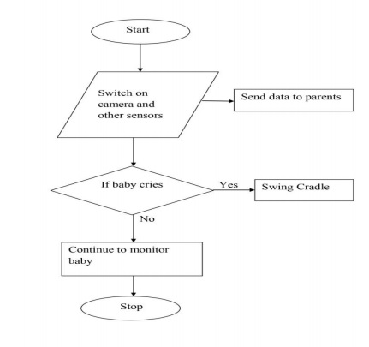

Fig.1 Smart Cradle System Flow Chart

Modules:

1. Raspberry Pi Operating System: The user can interact with smart cradle through raspberry pi operating system. The operating system consists of a python editor thonny. User can operate the cradle by running the main python code through thonny editor. User will be able to view all the sensor values in the thonny editor as well as whether e-mail is being sent or the servo motor is on or off.

2. Google Firebase: In this module the user will be able to control the servo motor as well as camera. The user has to specify the value of servo motor and camera (defined as e-mail) as either 0 or 1.Here the value 0 represents off and 1 represents on. Initially the value of servo motor and camera will be 0, user can change these values as 1.Once the value is 1 both the motor and camera will be on. Camera will take a snapshot of infant and email it to parents. While cradle will swing to sooth the baby. Additionally the firebase also displays temperature, humidity, wetness and movement values.

3. MobaXterm: Since raspberry pi itself is a computer, user needs an application to remotely access it via his/her computer. MobaXterm is an application used to remotely access raspberry pi. The user has to specify the ip address of raspberry pi which is connected to the internet via Ethernet cable or wifi to start a session. Once the session starts user needs to specify the username and password. Next step is to type startlxde to gain access to raspberry pi

4. Advanced IP Scanner: Advanced IP Scanner is an application used to locate raspberry pi in network.User needs to specify the ip address range in search bar and then press scan.Application will then display all the devices connected to network within the ip address range specified. Devices that are active in network are specified as live while one’s that are not active are specified as dead. User needs to copy the ip address of raspberry pi and then need to paste the same in mobaxterm application to gain access to raspberry pi.

Testing:

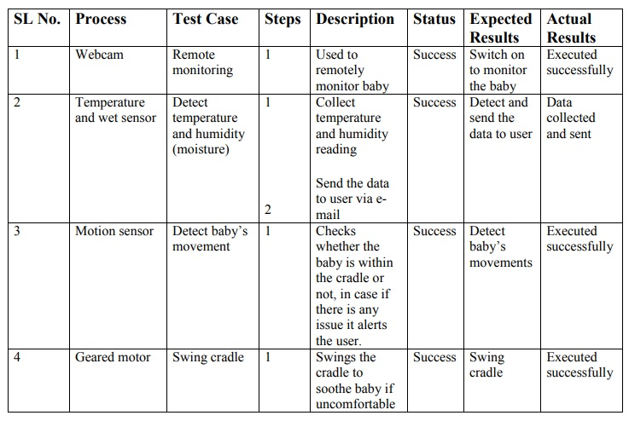

**CONCLUSION:** Growth of technology has rapidly increased. Since technology has been developed greatly it can contribute to the society in various way. Smart cradle system is the best example where working parents have lot of workload already and they have to take care of baby as well. Smart cradle system assures them that their baby is safe and secure inside the cradle. Cradle which is less expensive and more secure and has more features. As health of small baby is always a factor for which parents are worried. So this cradle system is built for that purpose. This smart cradle system would let the working mother do household works besides taking care of baby at the same time.

**REFERENCES**

[1] Prof. A. R. Patil, “Smart Baby Cradle an IOT based Cradle Management System.”, 2018 International Conference on Smart City and Emerging Technology (ICSCET).

[2] Prof. A.D. Anijkar et.al., “General Idea about Smart Baby Cradle”, Int. J. of Innovative Science and Eng., Jan-Feb 2014.

[3] Aquib Nawaz, “Development of an Intelligent Cradle for Home and Hospital Use”, National Inst. of Technology, 2015.

[4] Rachna Palaskar, Shweta Pandey, Ashwini Telang, Akshada Wagh, Ramesh R. Kagalkar, “An Automatic Monitoring and Swing the baby Cradle for Infant Care” Int.J. of Advanced Research in Computer and Commun. Eng., Dec 2015.

[5] Dhake, Swati. (2021). A Smart Baby Monitoring System an IOT based Smart Cradle System. International Journal for Research in Applied Science and Engineering Technology. 9. 635-642. 10.22214/ijraset.2021.35004.

[6]duman, ülkü & Aydin, Erdogan. (2020). IOT Based Baby Cradle System with Real Time Data Tracking. 10.1109/UBMK50275.2020.9219506

[7]Kshirsagar, Pravin. (2021). INTERNET OF THINGS-BASED BABY MONITORING SYSTEM FOR SMART CRADLE. Journal of Resource Management and Technology. 12. 217-225.

[8]Sharma, Siddharth & Bhatnagar, Swapnil & Hasan, Sharjeel & Jain, Vibhor & Patil, Amruta. (2021).

*****